EC DECLARATION OF CONFORMITY
1.
Product Identification No. AYR-HS-009 Hybrid PRO Sweatband Jumbo Size.
2.
Name and address of the manufacturer and/or his authorised representative:
Ayrtek Cricket Limited
51 Lewis Road
Bristol
BS13 7JD
3.
This declaration of conformity is issued under the sole responsibility of the manufacturer (or installer):
Ayrtek Cricket Limited
51 Lewis Road
Bristol
BS13 7JD
4.
Object of the declaration (identification of product allowing traceability. It may include a photograph, where appropriate):
Hybrid PRO Sweatband Jumbo Size (5 inch model)
There are numerous Colour variations.
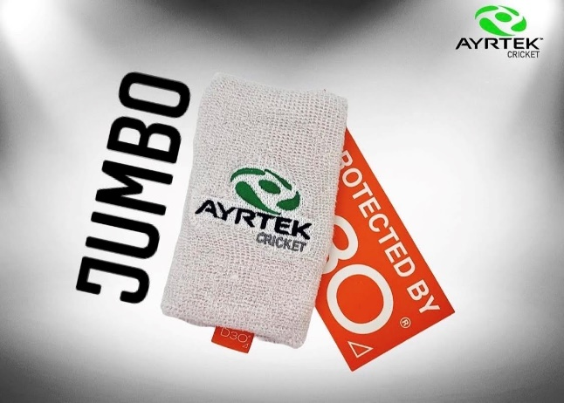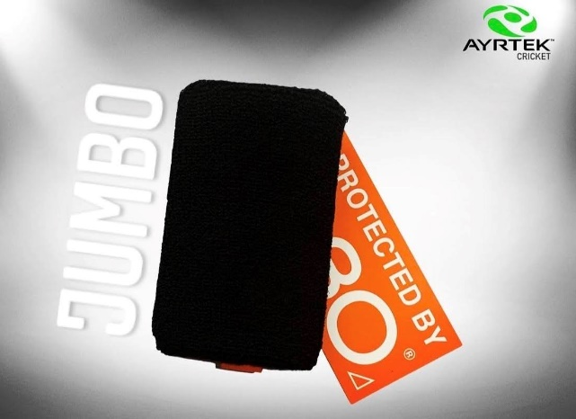

5.
The object of the declaration described above is in conformity with the relevant Community harmonisation legislation: REGULATION (EU) 2016/425 OF THE EUROPEAN PARLIAMENT AND OF THE COUNCIL of 9 March 2016 on personal protective equipment and repealing Council Directive 89/686/EEC
6.
References to the relevant harmonised standards used or references to the specifications in relation to which conformity is declared:
BS 6183-1:2000- Protective equipment for cricketers
BS 6183-3:2000- Protective equipment for cricketers Part 3: Leg protectors for batsmen,
wicket keepers and fielders, and thigh, arm and chest protectors for batsmen

7.
Where applicable, the notified body performed- BS 6183-1:2000
8.
Additional information:

Sweatband consisting of 80% Cotton, 12% Spandex and 8% Nylon
6mm Aero D3O
1.5mm HDPE Plastic layer
Signed for and on behalf of: Ayrtek Cricket Limited

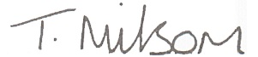
Tom Milsom, Company Director
Date- 01/01/2021

