EC DECLARATION OF CONFORMITY
1.
Product Identification No. AYR-BG-002 Youth Batting Glove.
2.
Name and address of the manufacturer and/or his authorised representative:
Ayrtek Cricket Limited
51 Lewis Road
Bristol
BS13 7JD
3.
This declaration of conformity is issued under the sole responsibility of the manufacturer (or installer):
Tandon International
Mandi Road
Jalandhar
Punjab
India
144001
+91-9888084321
tandon.international@yahoo.in
4.
Object of the declaration (identification of product allowing traceability. It may include a photograph, where appropriate):
Youth Batting Glove
There are 4 Colour variations of green, blue, gold and white.
They are available in 2 dexterities being Right Handed or Left handed model.

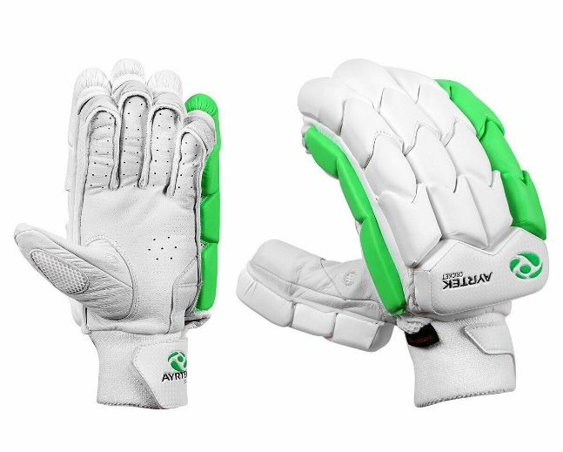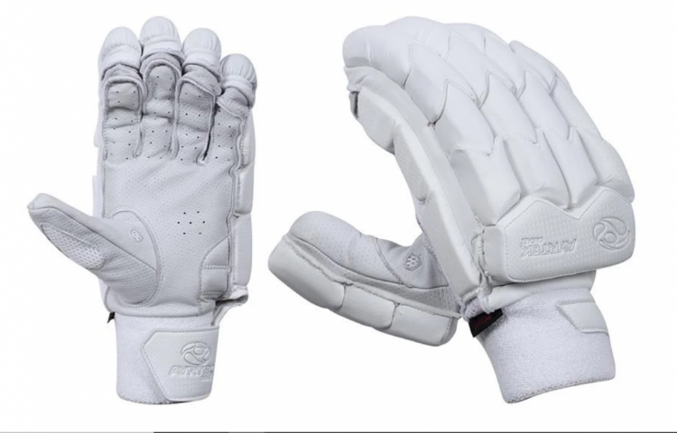
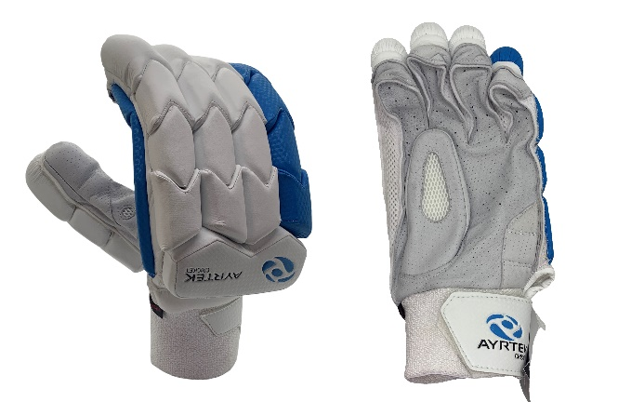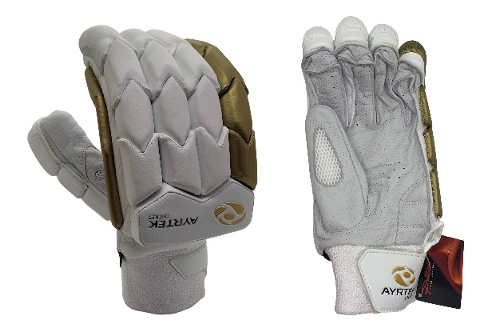
5.
The object of the declaration described above is in conformity with the relevant Community harmonisation legislation: REGULATION (EU) 2016/425 OF THE EUROPEAN PARLIAMENT AND OF THE COUNCIL of 9 March 2016 on personal protective equipment and repealing Council Directive 89/686/EEC
6.
References to the relevant harmonised standards used or references to the specifications in relation to which conformity is declared:
BS 6183-1:2000- Protective equipment for cricketers
BS 6183-4:2001- Protective equipment for cricketers Part 4: Gloves for batsmen
7.
Where applicable, the notified body performed- BS 6183-1:2000

8.
Additional information:

GLOVE MATERIALS

1 GLOVE IS MADE OF HIGHEST QUALITY KOREAN LOVELONE FOAM PADDING
2 PALM PITTARDS LEATHER WR100X
3 PROTECTION
A. ETHAFLEX SHEET 18MM HIGH DENSITY
B. 1MM PLASTIC FIBER ON ALL JOINTS
C. HARD PLASTIC FIBER CASING ON BOTTOM 2 FINGER JOINTS
D. UFOAM 10MM FOR SOFTNESS ON BACK HAND
Signed for and on behalf of: Ayrtek Cricket Limited

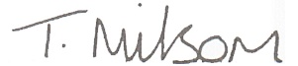
Tom Milsom, Company Director
Date- 01/01/2021

